# COMP3500: Process Control (Part 1)

**🟊: >85%, 🟊🟊: 70-85%, 🟊🟊🟊: 55-70%, 🟊🟊🟊🟊: 40-55%, 🟊🟊🟊🟊🟊: < 40%**

**Exercise 0-a (Plickers):** How often do you use a debugger (i.e., debugging tool) to develop software.

1. always
2. often
3. sometimes
4. never

**Exercise 0-b (Plickers):** How often do you use a version control tool (e.g., CVS, SVN, or Git) to carry out collaborative projects.

1. always
2. often
3. sometimes
4. never

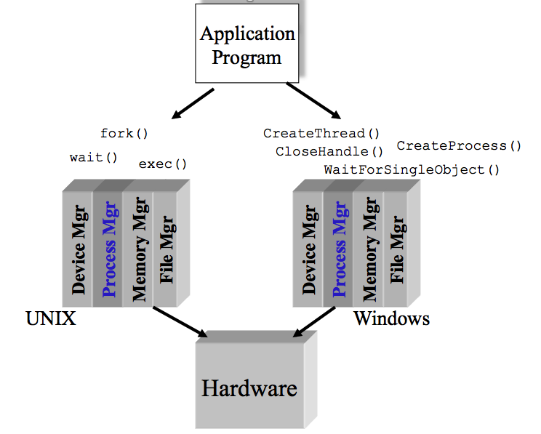**🟊🟊 Exercise 1 (Plickers):** Which one of the following is **not** a basic component in Microkernel? (30 seconds)

1. Process manager
2. Memory manager
3. IPC: inter-process communications
4. File manager

**🟊🟊🟊 Exercise 2 (Plickers):** Which one of the following items is **not** a design goal of a process manager? Hint: You should focus on OS management of application execution. (30 seconds)

1. To improve CPU utilization
2. To switch a processor among multiple processes
3. To allocate memory resources to processes
4. To use processor more efficiently

**🟊🟊 Exercise 3:** Which components does a ***running program*** have in a computer system? (1- minute group discussion) **Hint:** Can you list at least four items?